CREST Metadata Application
  - Center of Research Excellence in Science and Technology

  - Release 0.1

Revision history
Date | Person | Email | Summary
08/15/2018 | Hector Cen | hcen001@cs.fiu.edu | Created the document

Table of Contents
Summary 4
Application overview 5
Authentication 5
Files and Metadata 5
URL 5
Testing environment 5
Production environment 5
Walkthrough 6
Authentication 6
Login 6
Logout 7
Files and Metadata 8
Visualizing metadata 8
Adding metadata to an existing file 10
Uploading a file through the application 14

Summary

The CREST Metadata Application (hereinafter “application”) is a complementary application to the repository system (hereinafter “repository”) deployed earlier this year. While the repository serves as the main storage for the datasets, files, and documents, the application serves as the storage of metadata of such files.

The application itself is running as a client to the repository. Some core functionalities are mimicked in order to reduce the interaction steps needed to upload and organize files in the repository. The ultimate goal is to fully mirror the required functionalities of the repository into the application. Should any unimplemented advanced feature or action need to be performed directly in the repository, users will need to go and proceed in the repository.

The metadata attributes included in this application reflects the EDI Metadata Template 2016. Future iterations of the application will include discipline and field-oriented templates.

Application overview

Currently the application is divided into two modules: Authentication and Files and Metadata.

Authentication
Provides means to verify and validate the users of the system. Users will log in using the same credentials used in the repository, namely email and password. The application will fetch all the user data from the repository.

Files and Metadata
The main module of the application provides means for the user to manage files and the metadata associated to them.

URL
Currently the application is deployed on a testing environment, meaning that it is used to test its features, provoke and fix bugs, user training, etc. We will have two environments, one for testing and another for production, which will host the latest stable and live application to all users.

The URL to access the application are:

Testing environment
http://fabian-b.cs.fiu.edu:5000/

Production environment
TBA

Walkthrough

Authentication
Upon browsing to the application’s URL, the application will display the authentication page if the current user is not authenticated, otherwise it will show a page from one of its modules.

Login
- Open a web browser and go to: http://fabian-b.cs.fiu.edu:5000/
  - If the user is not authenticated, it will redirect to http://fabian-b.cs.fiu.edu:5000/auth/login/ and display the fields to enter username and password

  - If the user is already logged in, it will display a page within the application

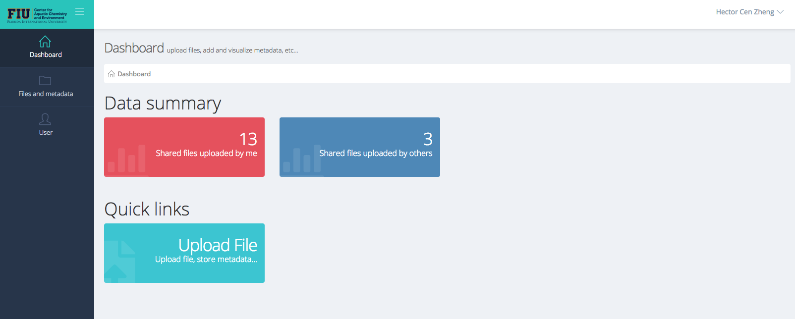

Logout

To log out of the application, you have two options.

- At the top-right corner of the application, when you click over your name, it will display a dropdown menu with the option to log out.
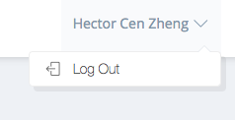
- Under the User menu in the left sidebar. When you mouse-over the User menu, it will display an option to log out.
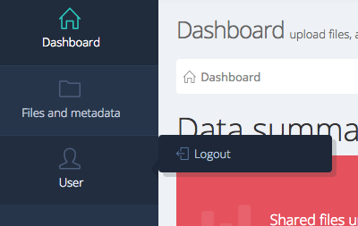

Files and Metadata

Visualizing metadata
The Files and Metadata module provides the means to add, edit, and manage the metadata for the files already in the repository or new ones to be uploaded through the application.

- To access this module, click on the Files and metadata item in the left sidebar
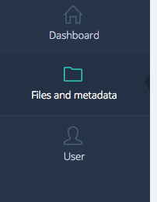
- Upon landing on the index page, you should see this page:
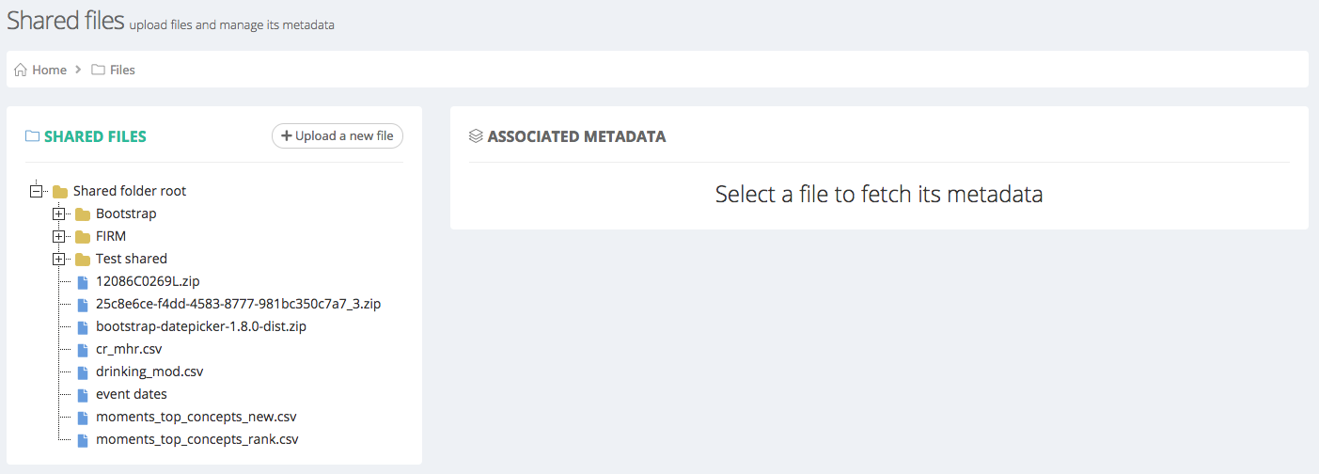
On the top of the page you will find descriptive information about the page and a breadcrumbs bar, that will indicate you in which section of the application you currently are. Then you will find two panels which will contain information about the files and the metadata.

The left panel is a directory tree mirroring the structure of folders and files in the repository. The right panel displays the current metadata associated to a file or the lack of it. In the latter case, a message will be included with a shortcut to add new metadata to selected file.

Whenever there is metadata associated to a file, the page will look like this:
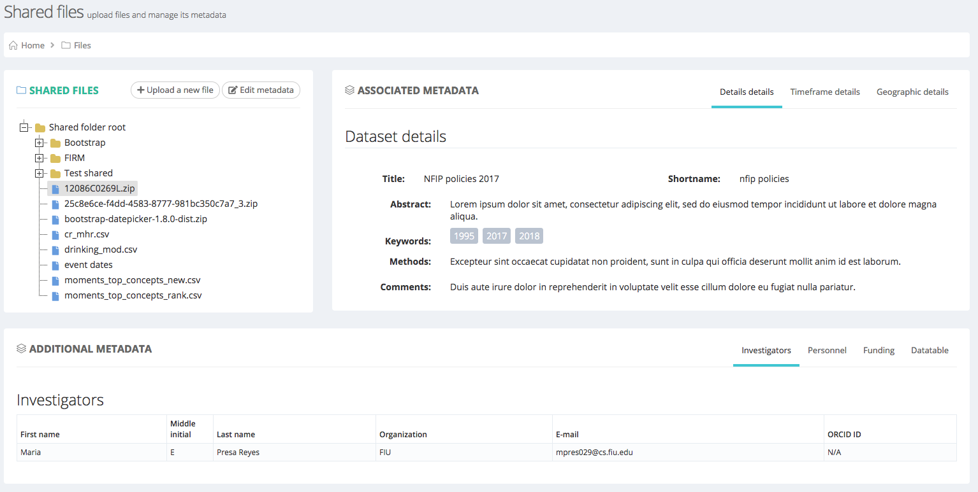

The panel on the right changes and now contains some metadata associated to the selected file. An additional panel appear at the bottom of the page containing additional metadata. Notice that both panels have tabbed panels in the top-right corner. When clicking on any of them, additional information is revealed.

When no metadata is associated to the selected file, the page will look like this:
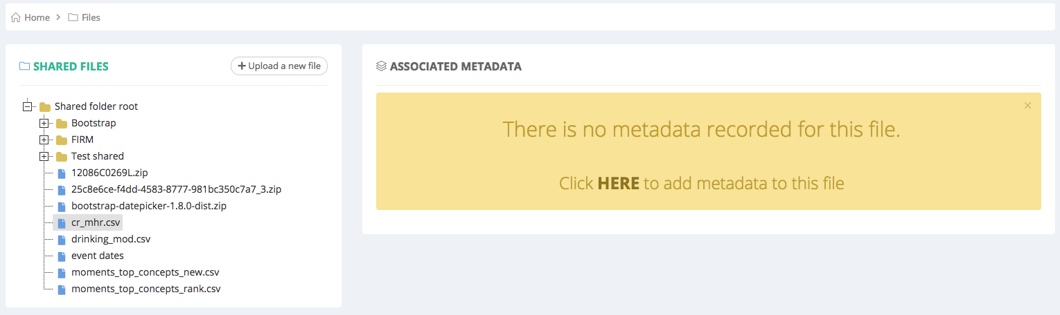
A message containing information will appear, along with a link that will allow you to go to the metadata add/edit screen.

Adding metadata to an existing file
Whenever a user uploads a file through the repository, no metadata will be attached to it, except for the one for the repository use and consumption. Files will be displayed in the application though, and more importantly, it will allow users to add metadata to them.

Let’s take a look at an example of this scenario. Let’s use the same file as we used in the previous example: cr_mhr.csv
After clicking on HERE, the add/edit metadata page will appear:
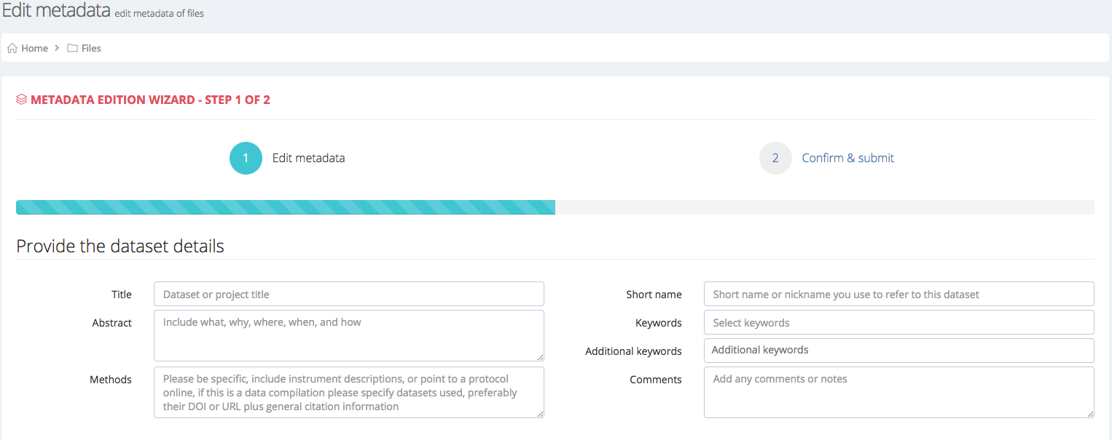
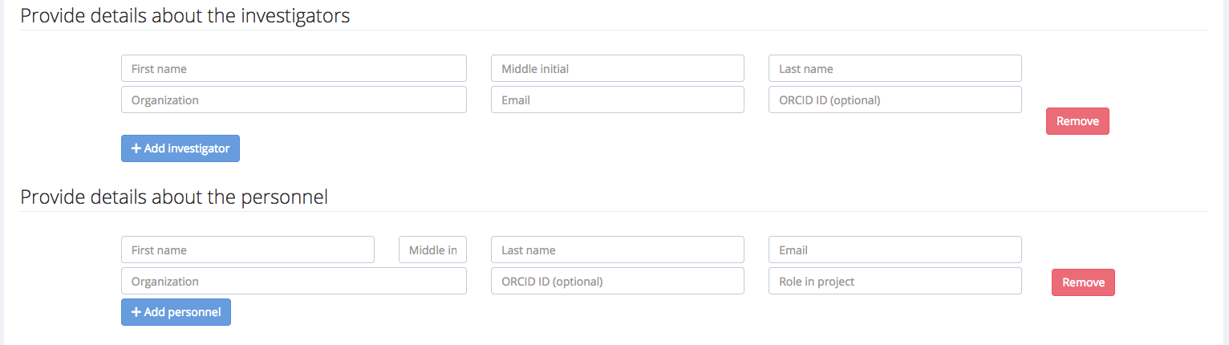

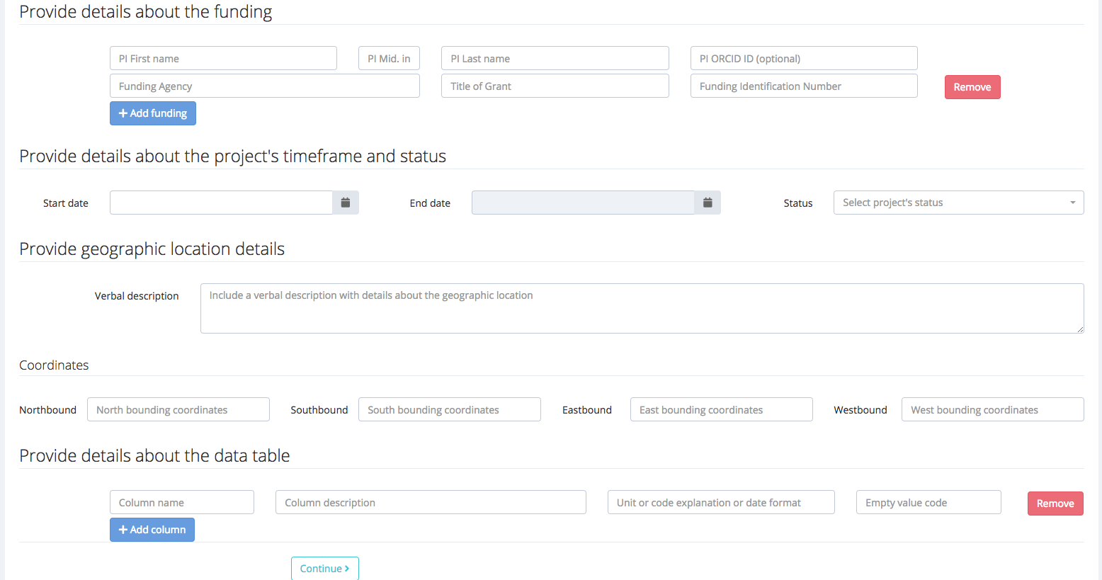
It is a 2-steps wizard-like page that will allow you to input all the required metadata for any given file. Placeholder text will indicate what is required in each field. For the fields in investigators, personnel, funding, datatable, you can add 1 or more items, using the Add ... button.

A filled form will look like this:
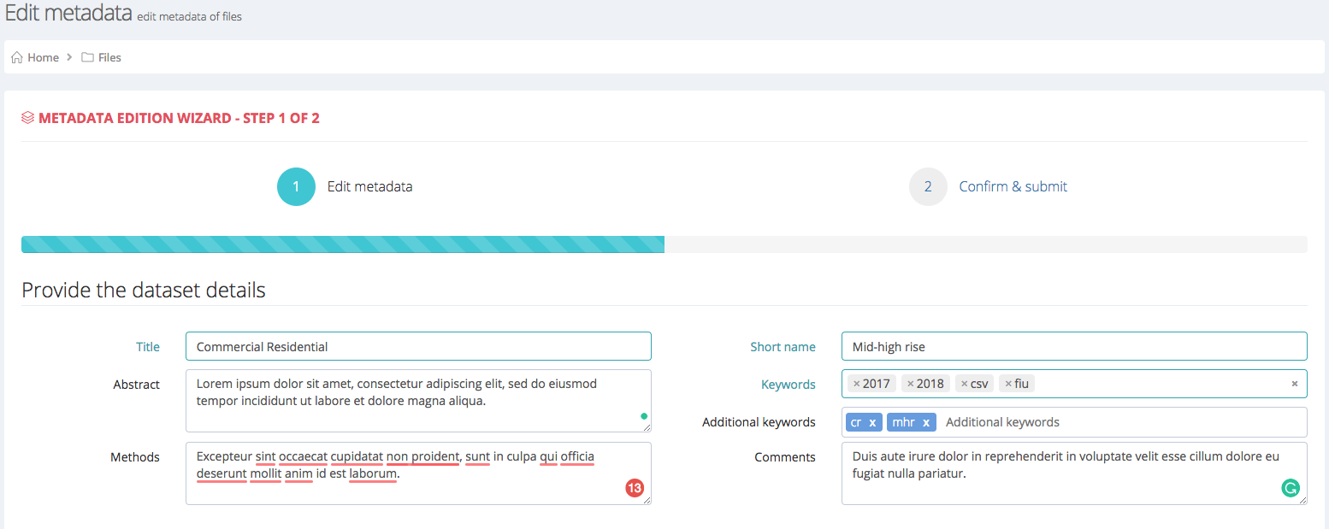
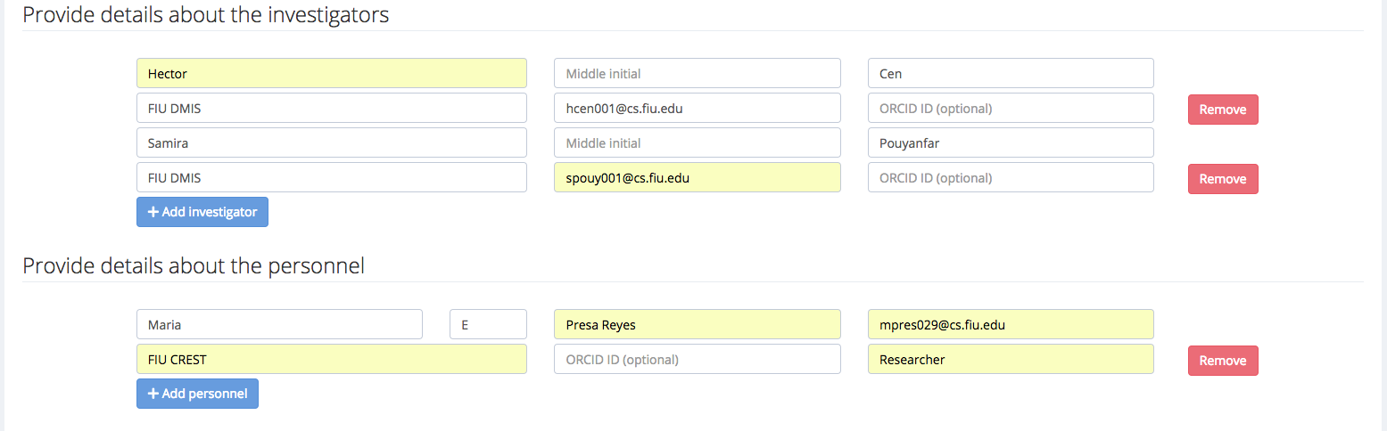
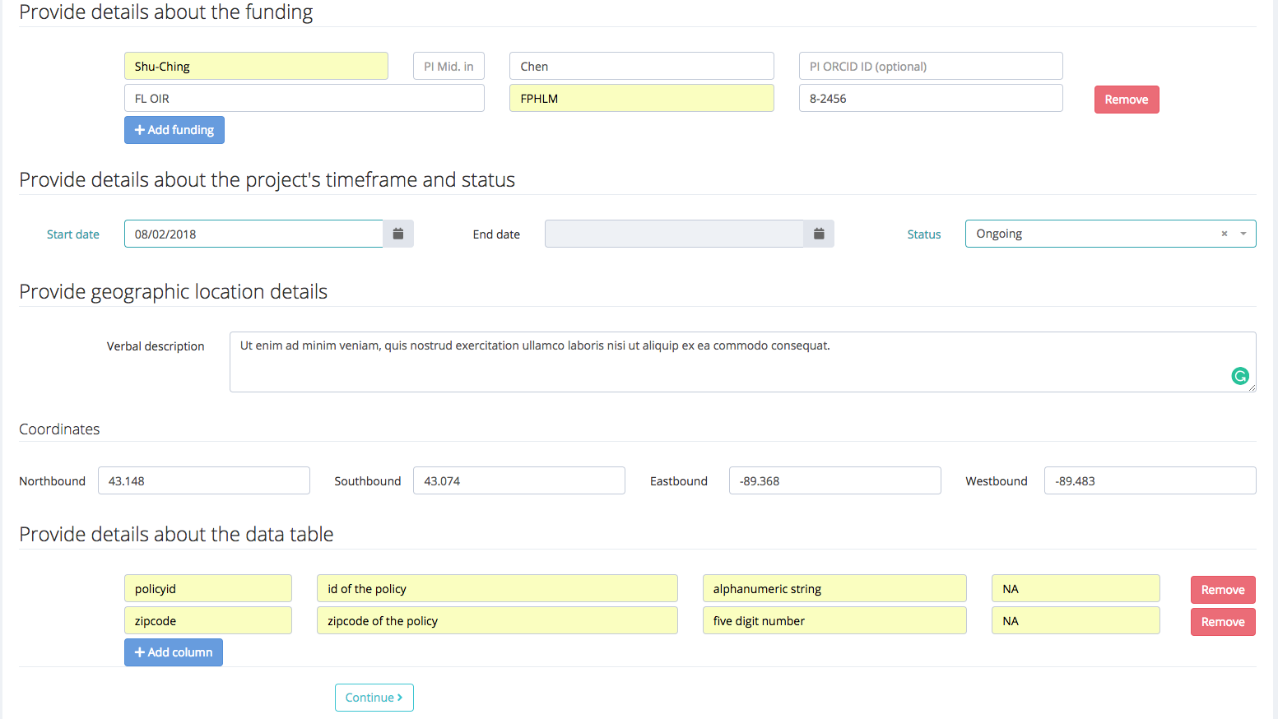
Once the data to be added is complete, you can click the Continue > button. The application will display now a summary before submission. It will look like this:
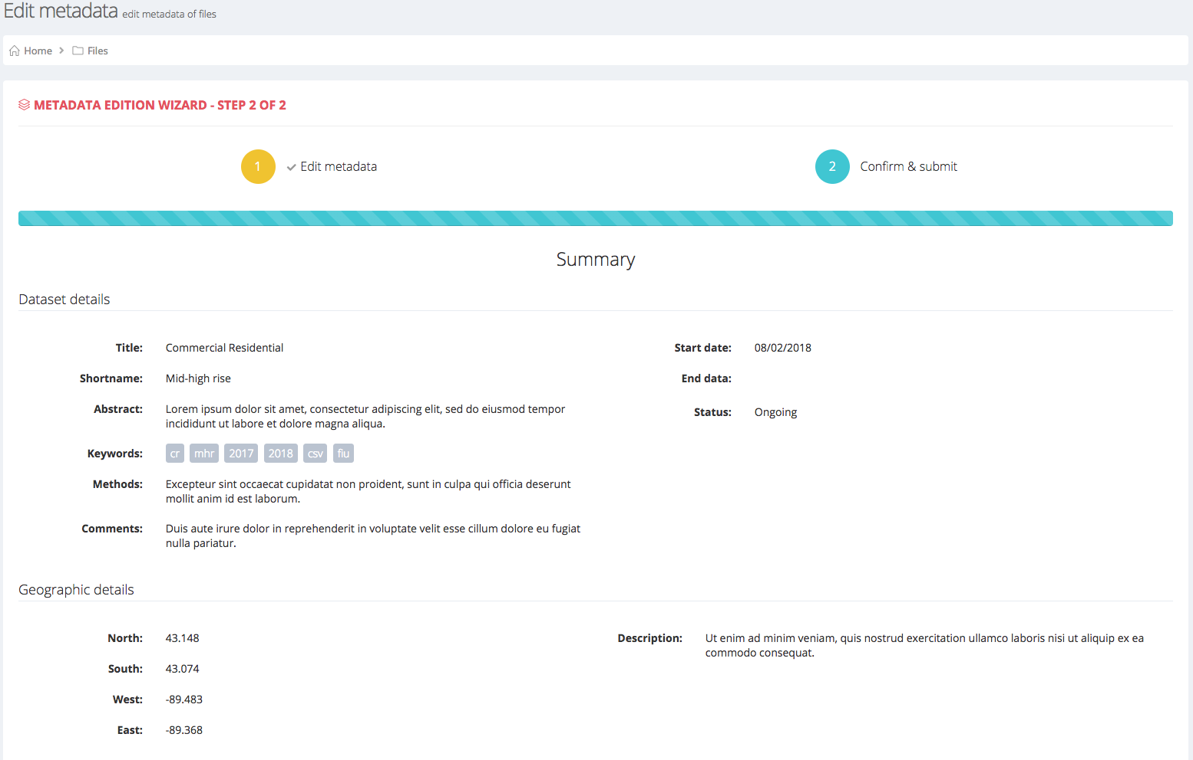

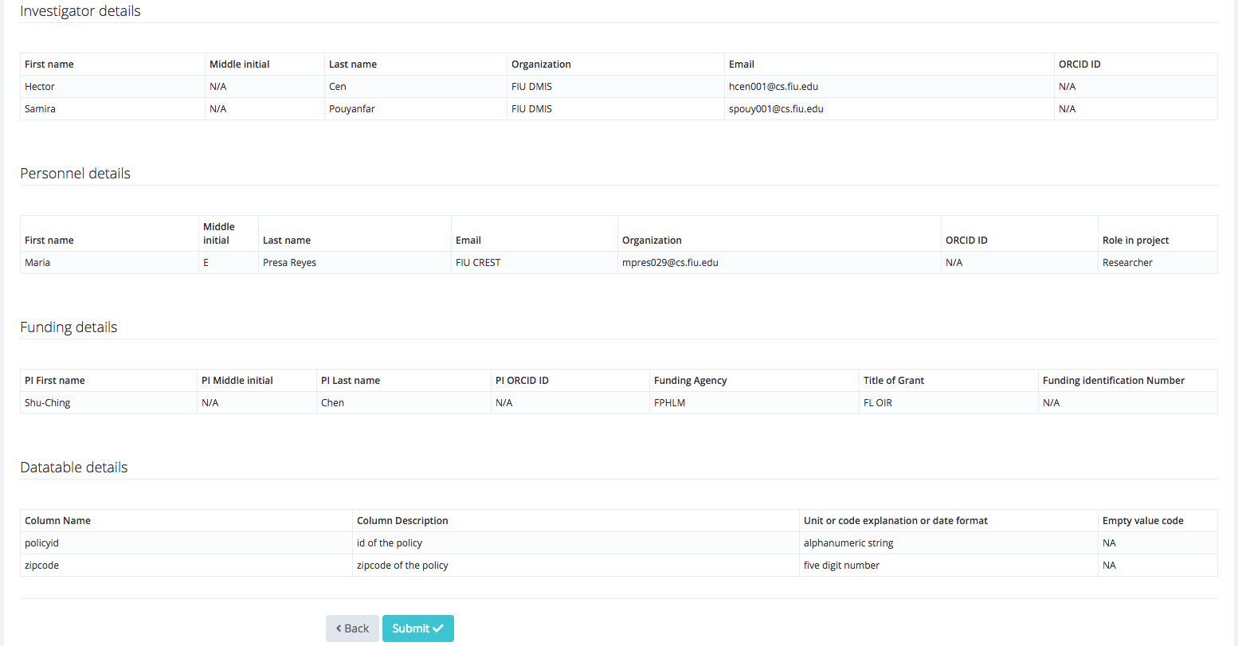
If everything is correct, you can click on the Submit √ button and the application will try to store the metadata in its database. Notice that in the Investigators section there are two items. Whenever you add more than 1 item in each of the sections that allow lists, all the items should be displayed here in the summary.
After submitting, if everything goes fine, we can inspect the file again to see that in fact, the metadata has been recorded:
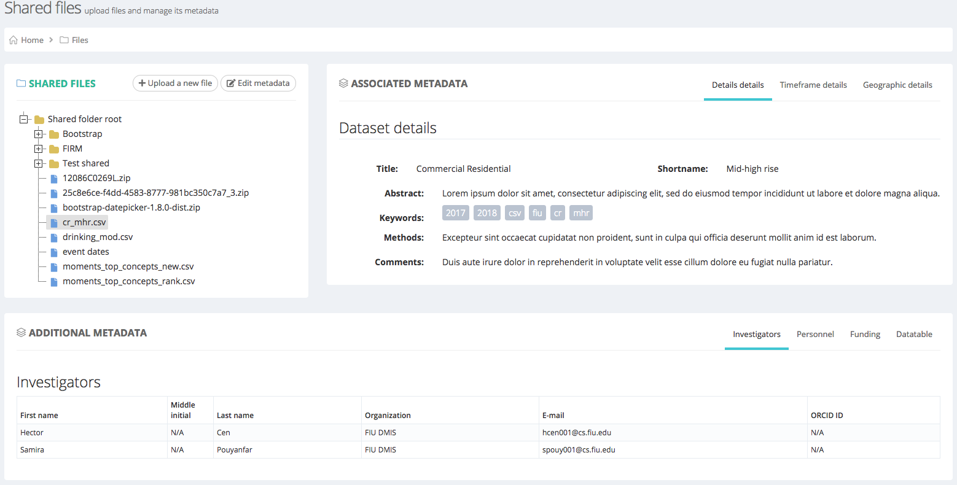
Sometimes mistakes can happen, in that case you can edit the metadata you just added, by clicking on the Edit metadata button on the top-right of the left panel. It will take you to the add/edit metadata screen with all the data you entered.

Uploading a file through the application
This will be the most common use case. Users will upload the file to the repository and at the same time add the metadata in a single workflow.
The only difference is that an additional step is added before the metadata input, namely the selection of the file to be uploaded and the selection of the destination folder in the repository.

Users have two ways to start the upload process through the application:
- Through the Upload file shortcut link in the Dashboard
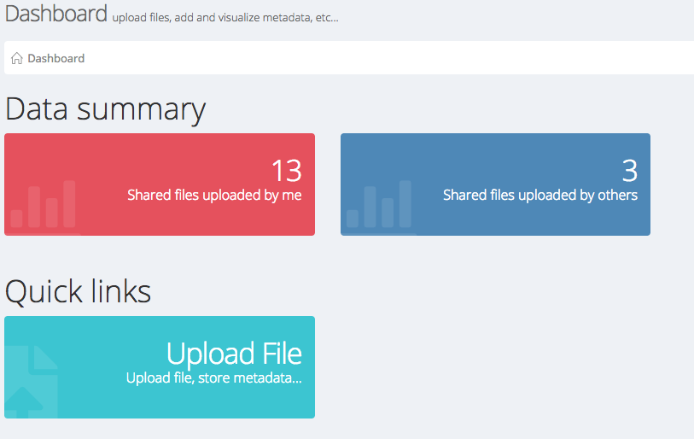
- By clicking on the + Upload a new file button in the Files and metadata module
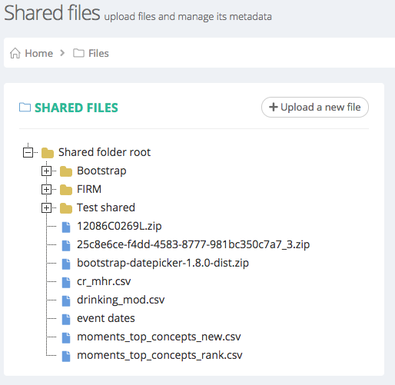

Once you access the file uploading module, you should see a screen like this:
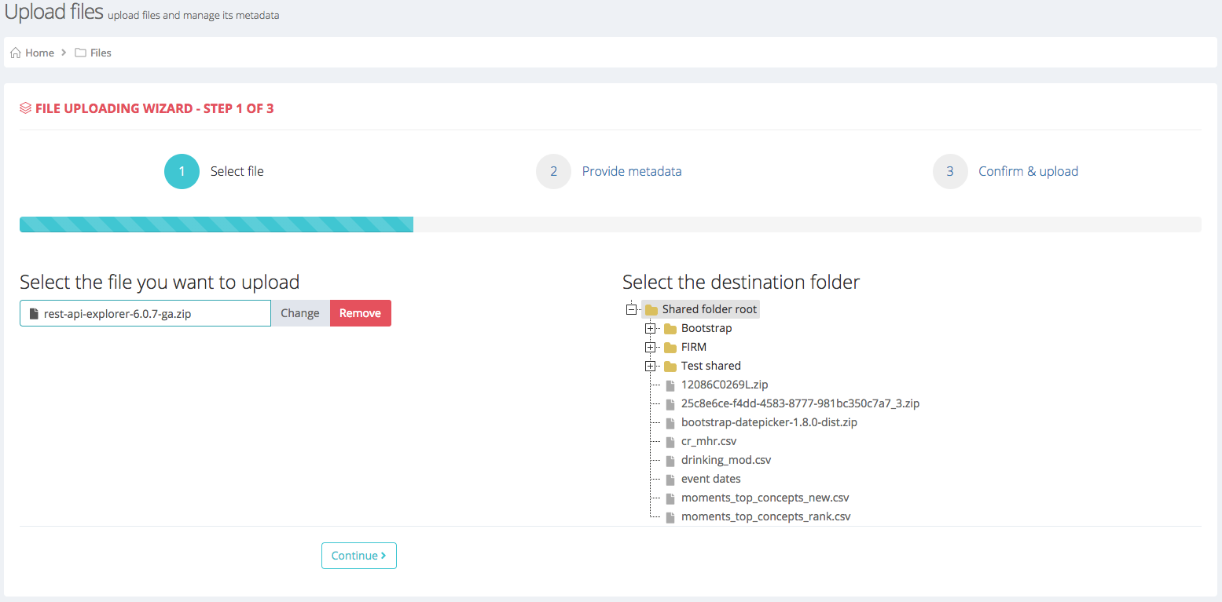
The process to upload a file is quite simple. The left side of the form lets you select the file you wish to upload. The right side of the form lets you select in which folder you want the file to be uploaded. If you don’t select a folder, the Shared folder root will be the destination.

In the figure we can see that the file to be uploaded is called rest-api-explorer-6.0.7-ga.zip and it will be uploaded to the Shared root folder. The following steps are exactly the same as adding/editing metadata.

Please note that the header in the wizard now displays 3 steps instead of 2 when adding/editing metadata.

http://crest-cache.cs.fiu.edu

